DAY 5

DEVOPS

CREATE AN NEW REPOSITORY:

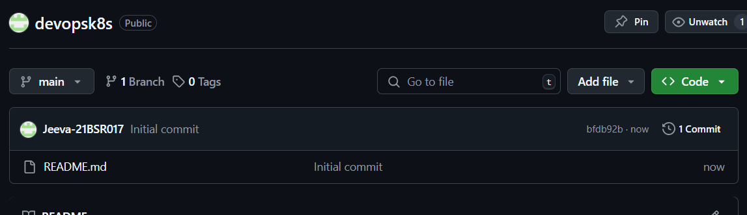

ADD THE FILES FROM LOCAK TO REMOTE:

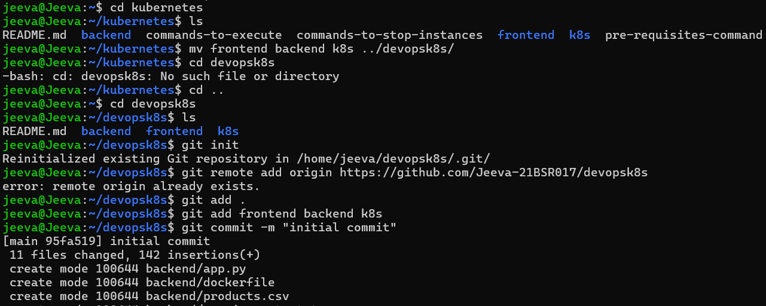

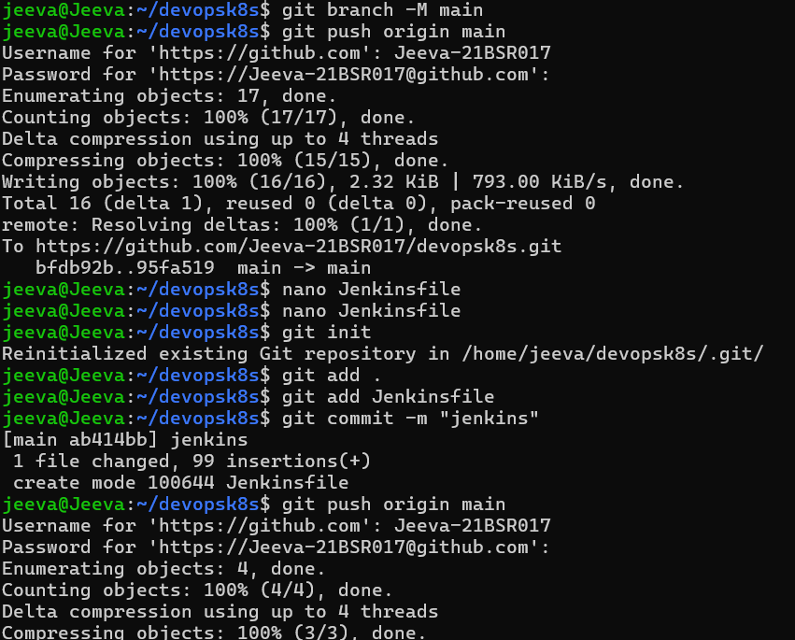

ADD JENKINS FILE

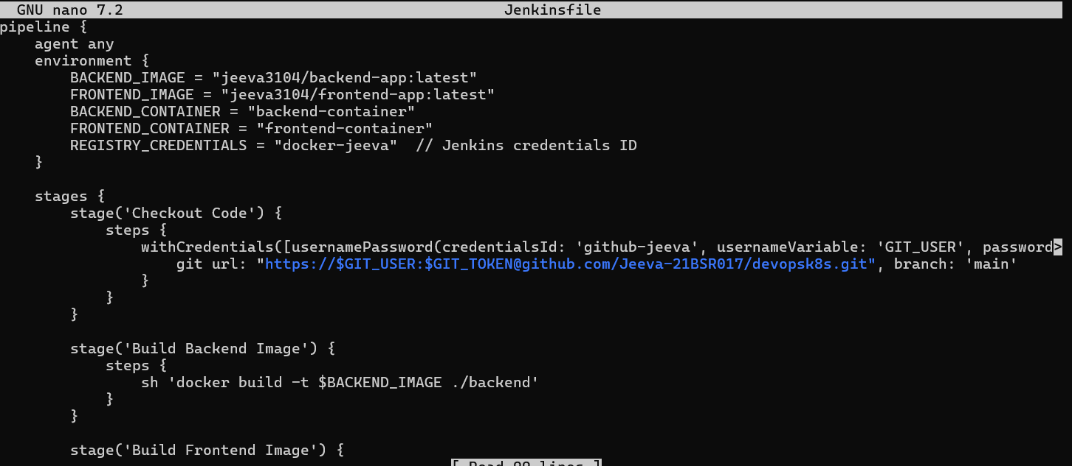

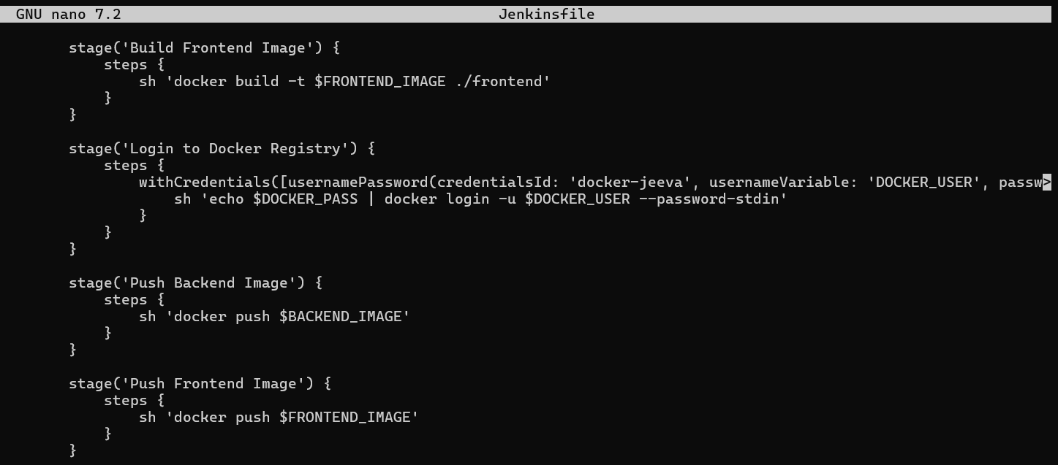

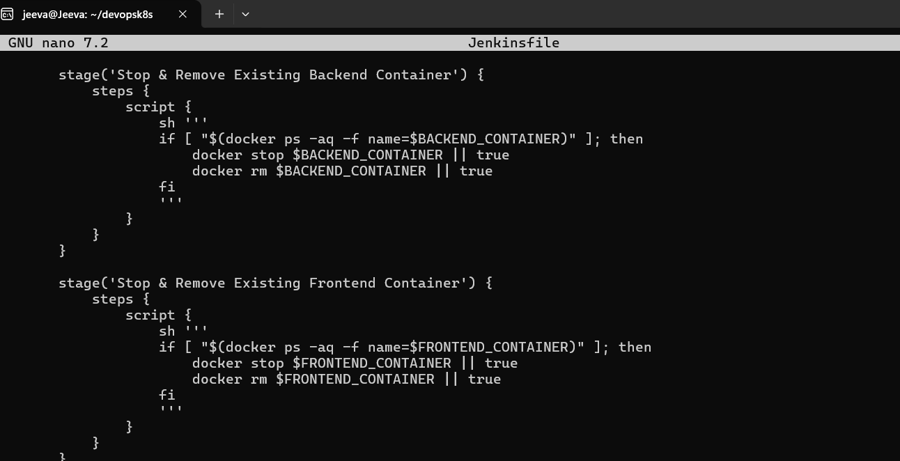

AFTER ALL THE PROCESS IN GITHUB THE CODES HAS BEEN ADDED

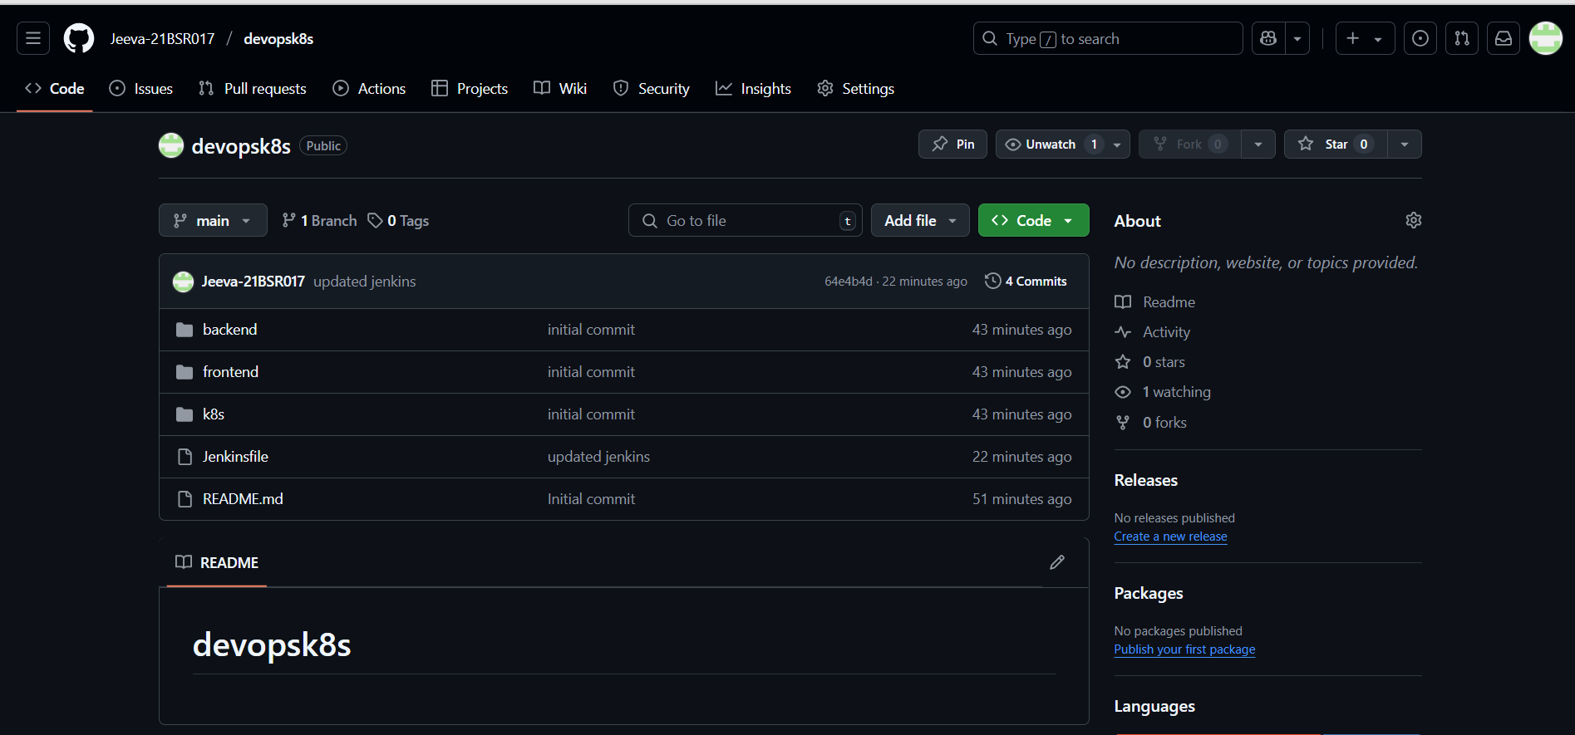

IN JENKINS ADD A NEW ITEM WITH PIPELINE AND ADD GITHUB REPO THEN BUILD THE PROCESS

